Katerina Betts and Donald Hutchinson

Professor Charles Zimmer

Data Structures

27 February 2018

Lab 6: Stacks and Queues

Task Two:

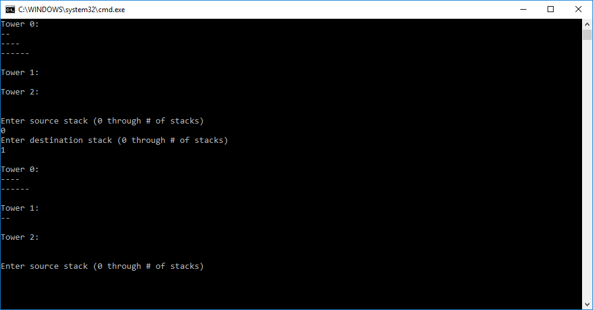

Move

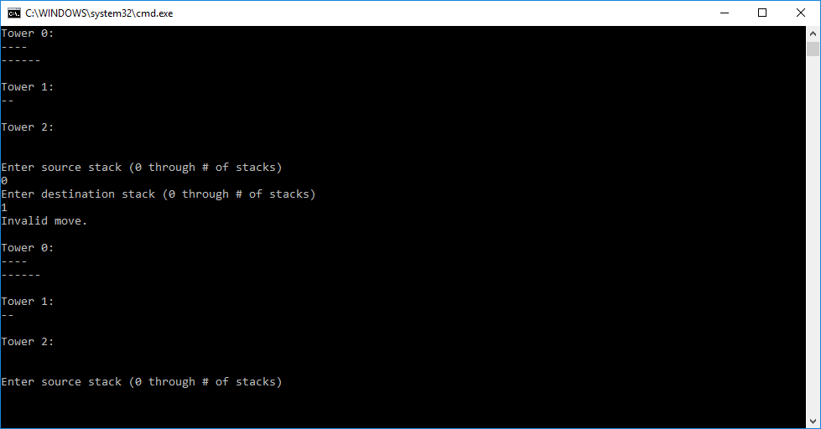

Error

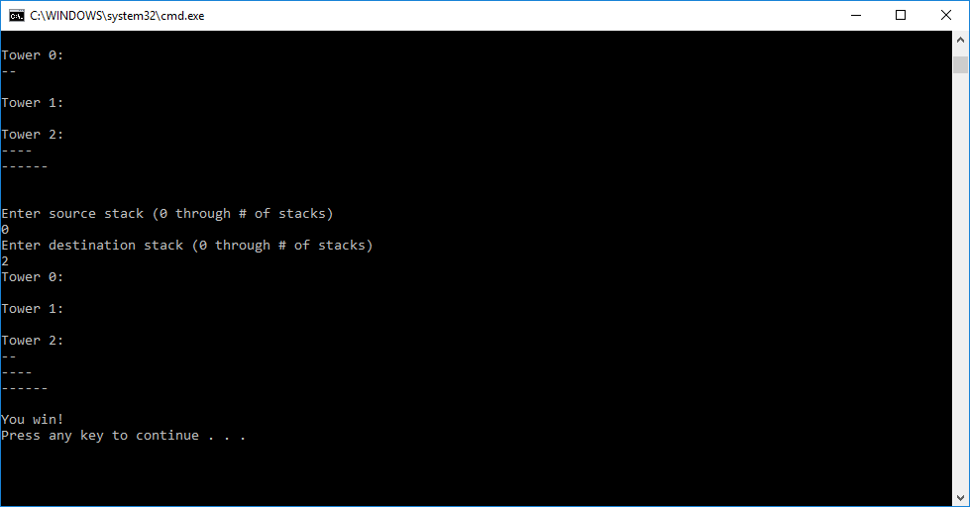

Win

Task Three:

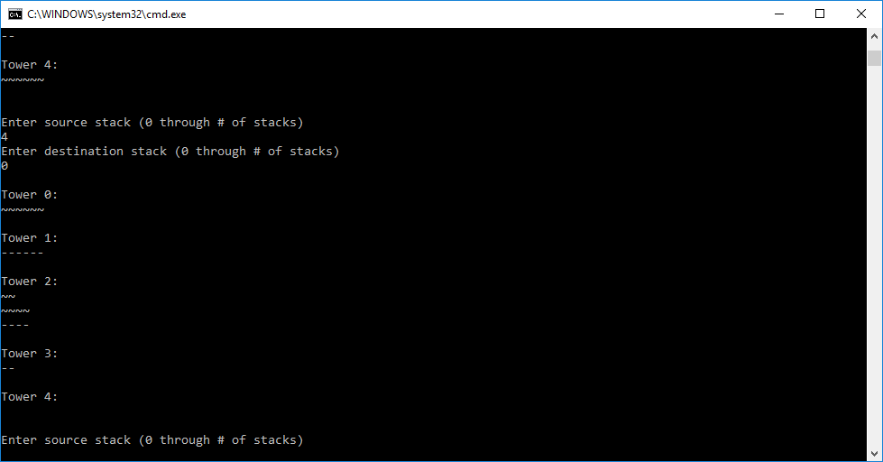

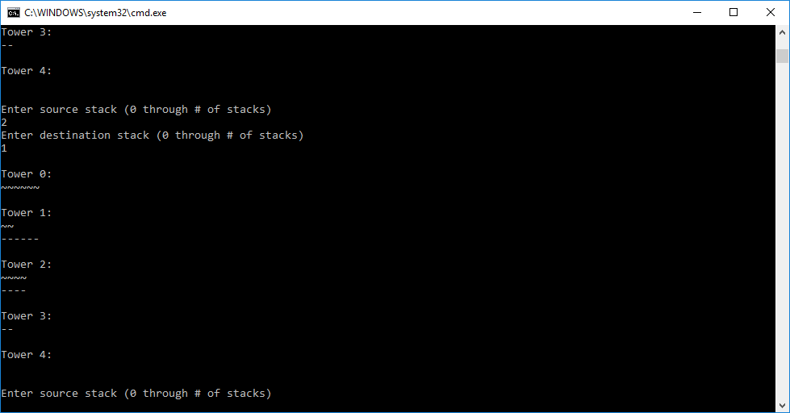

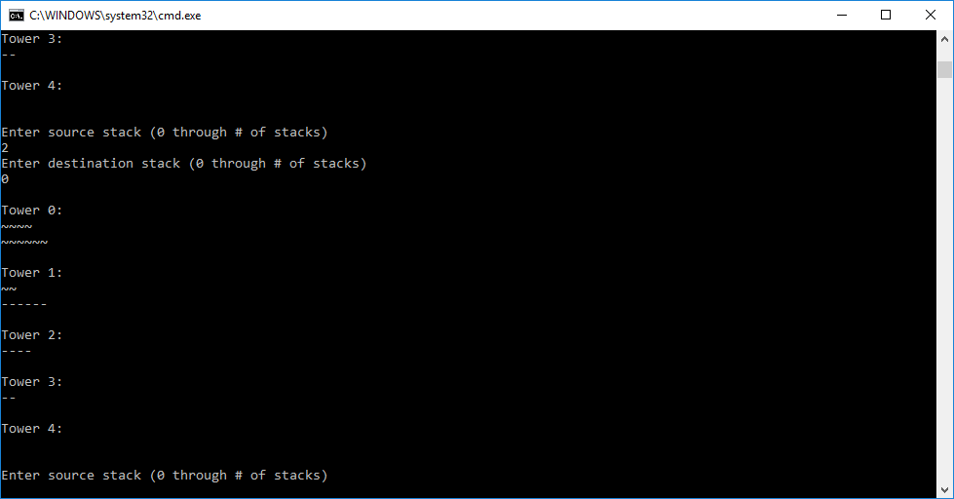

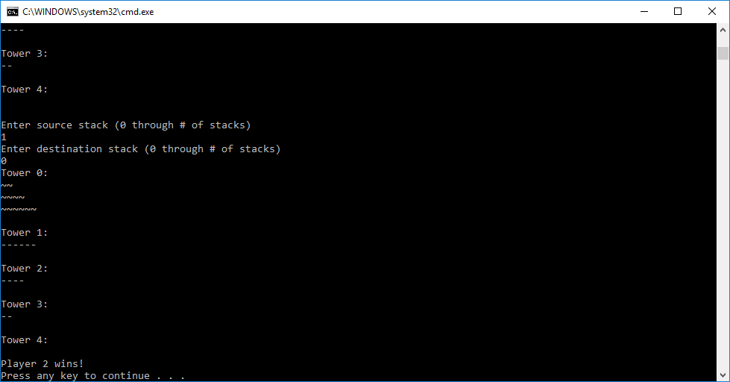

When it comes to strategies when playing the multiplayer Towers of Hanoi creation, it is sufficiently honest to say strategy went out the window. The strategy utilized the most was to just ignore the other player entirely because it is almost impossible to predict what another player will do unless there is only one legal move on the board. Cooperative was utilized in order to make sure the function worked; however, it was not used in a two-player sense to actually play the game, only to test it and try to make sure there were no bugs in the code.

Task Four:

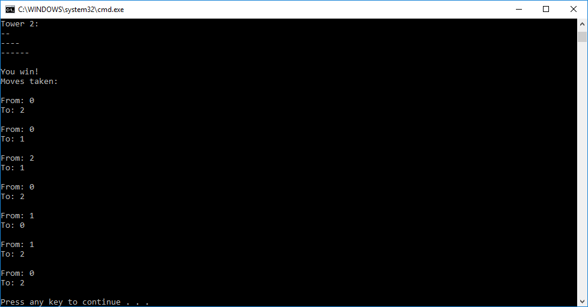

The move data structure was designed after the creation of the queue.